What cities could use my home safety gun course

**ASK:**

Questions to guide the case study

1. What type of company does your client represent, and what are they asking you to accomplish.
2. **I am representing myself and I would like to know in which state I should push my home safety gun course**
3. What are the key factors involved in the business task you are investigating
4. **Finding what states have the most mass shootings**
5. **Seeing which of these states are democrat run**
6. What type of data will be appropriate for your analysis
7. **My dataset includes number of date, state, number of dead, injured and total number of dead and injured.**
8. Where will you obtain data
   1. <https://www.kaggle.com/datasets/hemil26/mass-shootings-in-united-states-20182022>
9. Who is your audience, and what materials will help you present to them effectively
   1. **My audience is the people who are in constant fear of the next home invasion because of how dangerous their state is. These people need piece of mind when it comes to their personal safety.**

Guiding questions

1. What topic are you exploring
   1. **Where to expand my business**
2. What is the problem you are trying to solve
   1. **What state to make my number one priority**
3. What metrics will you use to measure your data to achieve your objective
   1. **I will be using the amount of victims in the total number of mass shootings as well as location.**
4. Who are your stakeholders
   1. **Myself**
5. Who is your audience
   1. **The people who want to know how to defend themselves and their family**
6. How can your insights help your client make decisions
   1. **It will tell me where the largest amount of mass shootings happen. By doing that it will tell me where people feel afraid they could be next so they will want to know how to intelligently defend themselves**

Key tasks

1. Identify the business task
   1. **In what state do I want to focus my attention selling my home safety gun course**
2. Determine stakeholders
   1. myself
3. Choose dataset
   1. **Mass Shootings in United States (2018-2022) - Kaggle**
4. Establish metrics
   1. **What state, how many dead, how many injured**

Deliverable:

1. A clear statement of the business task you have selected to investigate:
   1. ***What state in America has the most mass shootings so I know where to focus my selling of my home safety gun course.***

**Prepare:**

1. Where is your data located
   1. **On a local hard drive**
2. How is the data organized
   1. **By state, dead, injured and total**
3. Are there issues with bias or credibility in this data
   1. **Not that i found**
4. How are you addressing licensing, privacy, security and accessibility
   1. **Its open source data**
5. How did you verify the datas integrity
   1. **Double checked its authenticity with original source**
6. How does it help you answer your question
   1. **By showing me what state have the most mass shootings I know where to advertise my course**
7. Are there any problems with the data
   1. **Not that i saw, pretty straight forward**

Deliverable:

1. A description of the data source
   1. The data source is a five year snapshot at the amount of mass shootings per state, how many died and how many got injured.

**Process:**

1. What tools are you using and why
   1. Bigquery because I want to increase my SQL skils
2. Have you ensured your datas integrity
   1. Yes
3. What steps have you taken to ensure that your data is clean
   1. I went through it quickly and there was no outliers or anything that would cause me to take notice
4. How can you verify that your data is clean and ready to analyze
   1. There are no outliers and things look like they make sense
5. Have you documented your cleaning process so you can review and share those results
   1. Yes

Deliverable:

1. Documentation of any cleaning or manipulating of the data
   1. Code:

* After downloading the Mass Shootings dataset I uploaded it into bigquery
* I separated the data into the relevant tables for the business question and those were state, dead, injured and total.
* I added the totals for each year

SELECT state AS State,

SUM(dead) AS TotalDead,

SUM(injured) AS TotalInjured,

SUM(total) AS TotalVictims

FROM (

SELECT state, dead, injured, total

FROM Mass_Shootings.shootings_2018

UNION ALL

SELECT state, dead, injured, total

FROM Mass_Shootings.shootings_2019

UNION ALL

SELECT state, dead, injured, total

FROM Mass_Shootings.shootings_2020

UNION ALL

SELECT state, dead, injured, total

FROM Mass_Shootings.shootings_2021

UNION ALL

SELECT state, dead, injured, total

FROM Mass_Shootings.shootings_2022

) AS all_shootings

GROUP BY state

ORDER BY TotalDead DESC;

**Analyze:**

1. How should you organize your data to perform analysis on it
   1. **I should organize it by state, injured, dead and total injured and dead**
2. Has your data been properly formatted
   1. **Yes**
3. What surprises did you discover in the data
   1. **That Texas was one of the leaders in mass shootings**
4. What trends or relationships did you find in the data
   1. **That its pretty split between pro and anti gun states**
5. How will these insights help answer your business question
   1. **It doesnt really matter**

Deliverable:

1. A summary of your analysis:
   1. **In conclusion, while it is an absolute tragedy that the amount of mass shootings are happening, it does create an opportunity to help to empower those who are caught in the crossfire to at minimum have a fighting chance at staying safe within their own homes**

**Share:**

1. Were you able to answer the business question
   1. **Yes**
2. What story does your data tell
   1. **That there are a lof of mass shootings and the people stuck in the crossfire need something to help them survive**
3. How do your findings relate to your original question
   1. **By directly showing me where i should focus my attention**
4. Who is your audience, what is the best way to communicate with them
   1. **My audience is anyone who wants to increase their chances of staying alive and how we will communicate with them will be the next project**
5. Can data visualizations help you share your findings
   1. **Yes by showing pictures of the data**

Deliverable:

1. Supporting visualizations and key findings

a.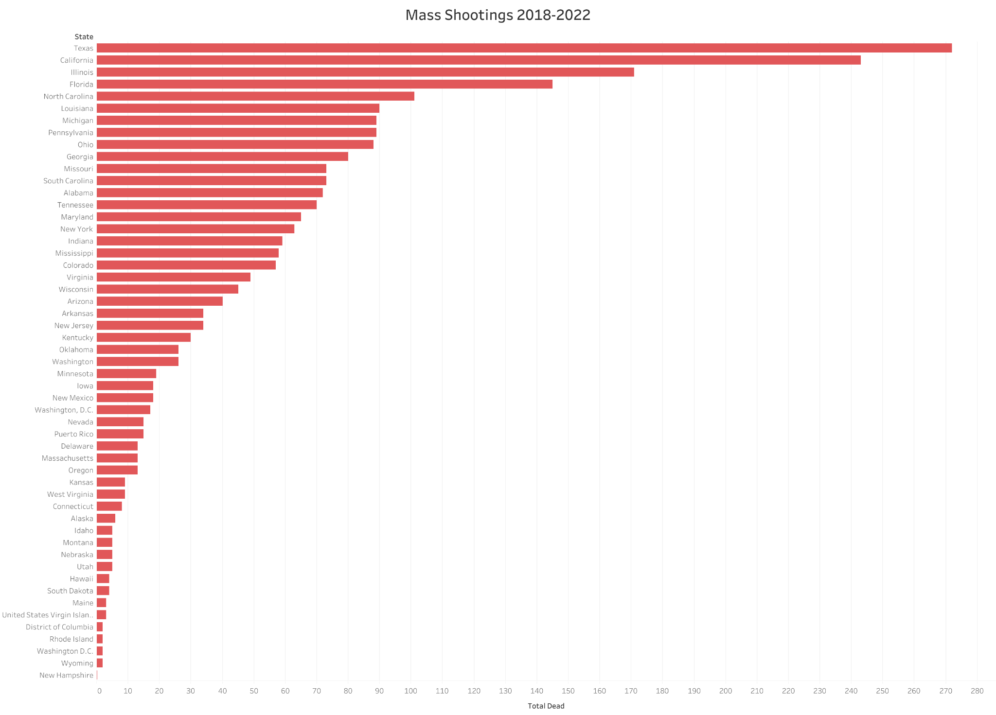

b.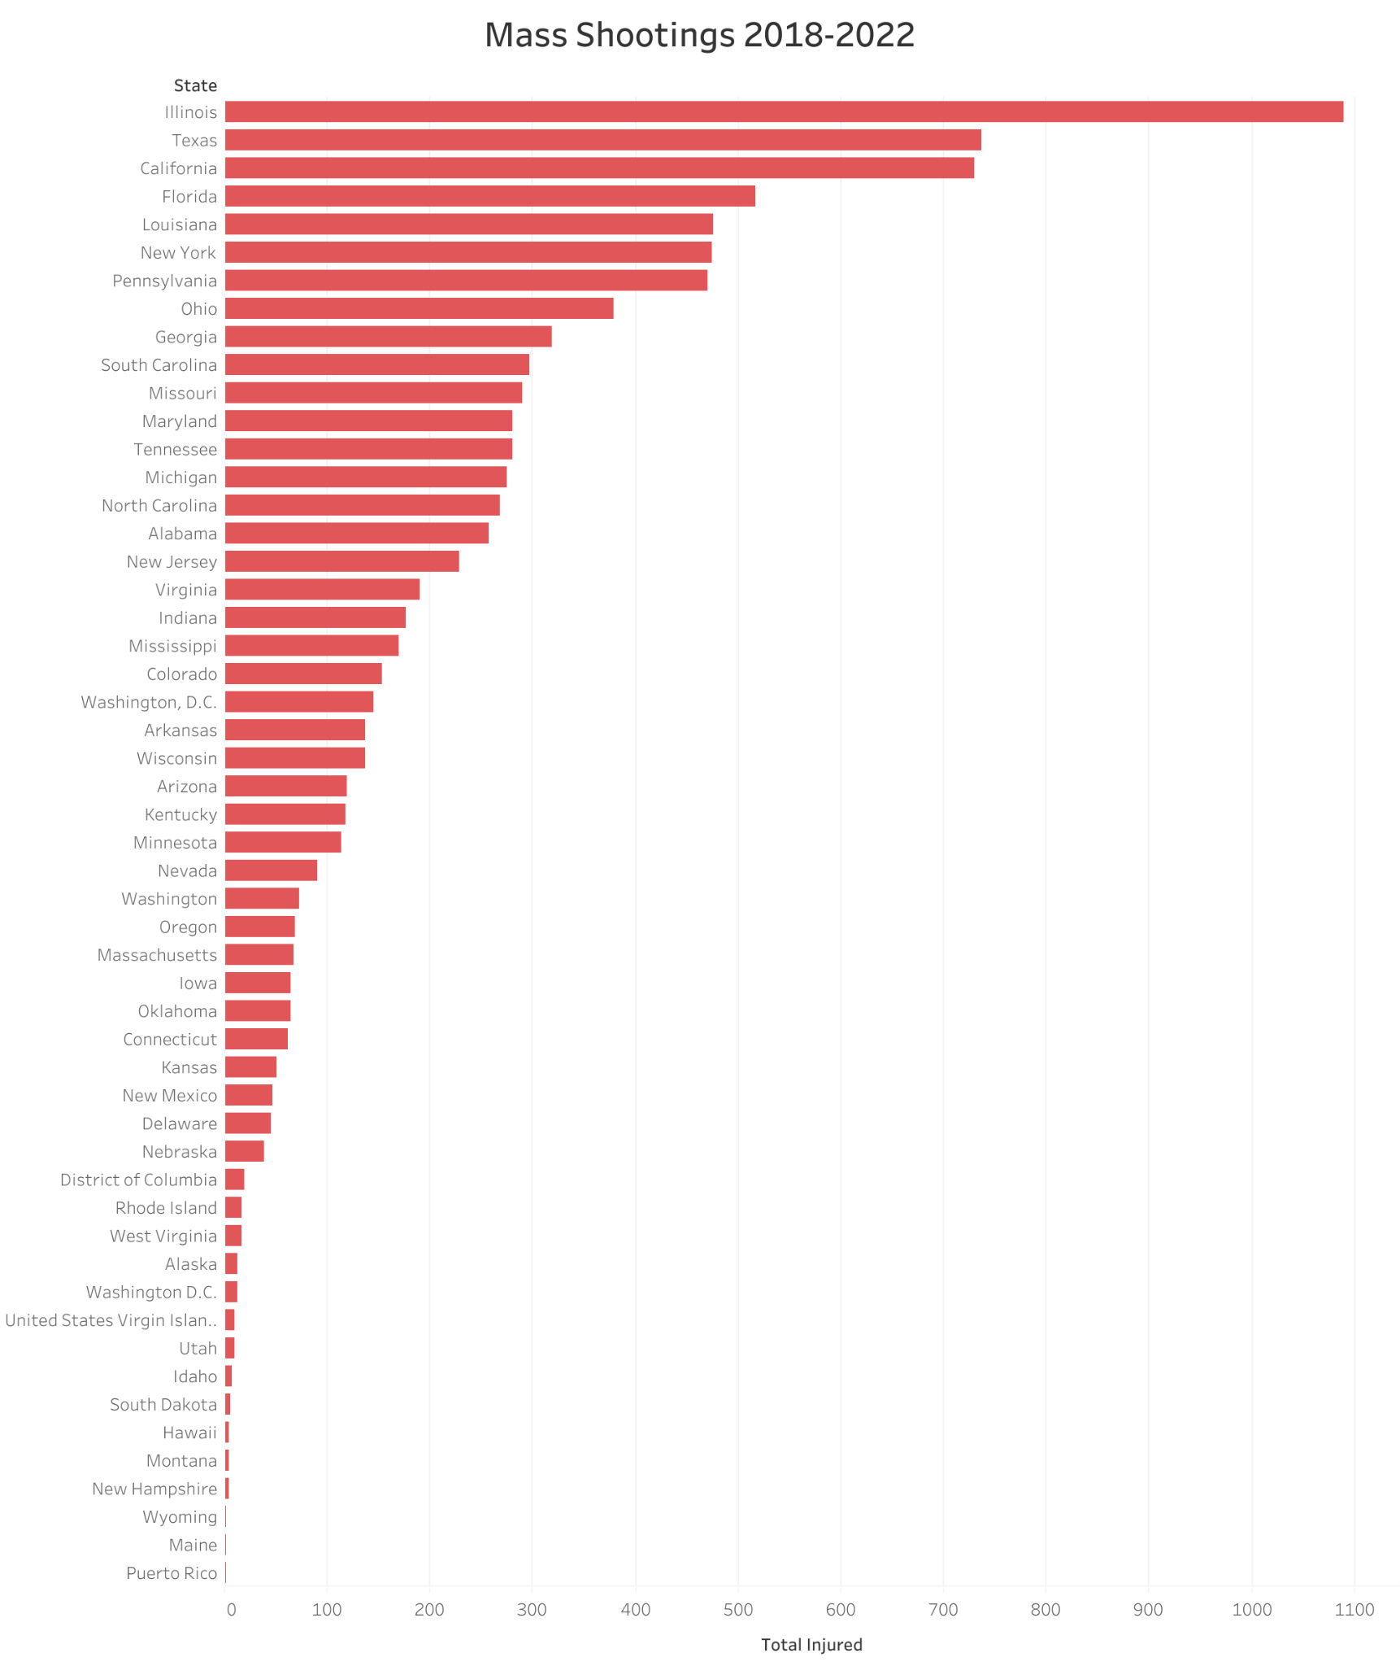

c.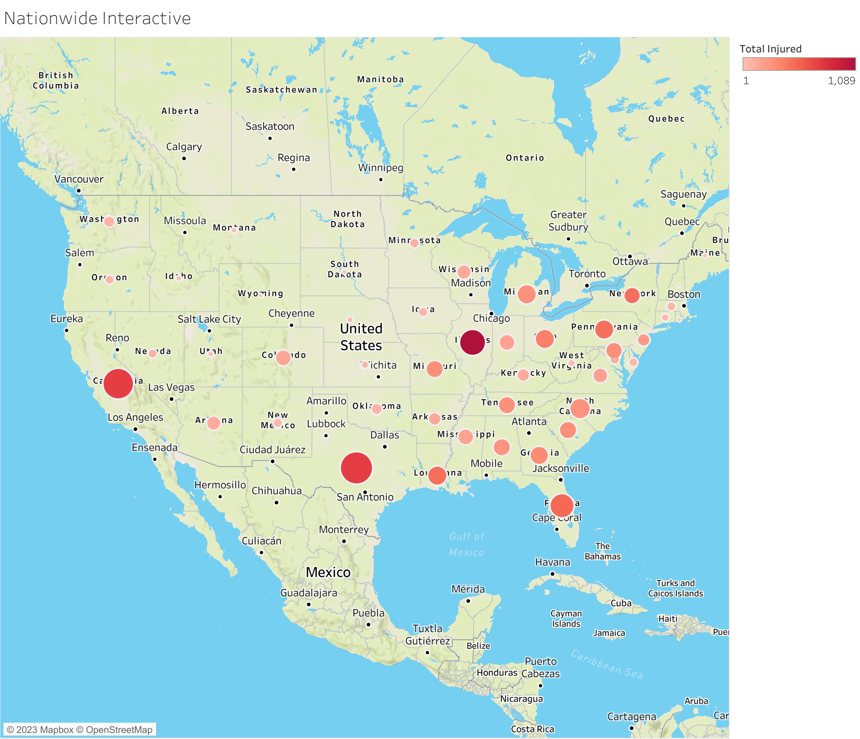

**Act**:

1. What is your final conclusion based on your analysis
   1. **There are a bunch of states that could use my course**
2. How could your team and business apply your insights
   1. **By creating marketing materials and advertising campaigns to implement in Illinois**
3. Is there additional data you could use to expand on your findings
   1. **It would have been better to use city data instead of state but this is what I had to this is what I used**